

**PROPOSAL:**

**CALL BILLING**

**Ministry of Education**

**Submitted by**

Mohi Karim

Verbanet Technologies LLC  
12.03.19

**DIRECTORY.**

**1** **KEY DETAILS** 4

**2** **STRATERGIC OBJECTIVES** 5

**3** **PROJECT SCOPE** 6

3.1 PROPOSED SOLUTION MODEL 7

3.2 FUNCTIONAL REQUIREMENTS 8

3.3 NON-FUNCTIONAL REQUIREMENTS (OTHERS) 9

3.4 TECHNICAL CONFIGURATIONS 9

3.4.1 DEVELOPMENT ENVIRONMENT 9

3.4.2 RECOMMENDED WED HOSTING PACKAGE - DEDICATED 10

3.4.3 BROWSER 10

3.4.4 HARDWARE DEVICES 10

3.4.5 TECHNICAL STANDARDS 11

3.4.6 TECHNICAL GUIDELINES 11

3.5 PROJECT DELIVERY 12

3.5.1 Agile Methodology 12

3.5.2 PROJECT MANAGEMENT 14

3.5.3 ROLES & RESPONSIBILITIES 15

3.5.4 DELIVERY ACTIVITY SUMMARY 16

3.5.5 PROJECT IMPLEMENTATION PLAN 17

3.5.6 DELIVERABLES 17

3.5.7 ESTIMATED DELIVERY TIME 18

3.5.8 DEPLOYMENT DETAILS 20

3.5.9 RELEASE PLANNING 20

3.5.10 RISK CONTINGENCY PLANNING 20

3.6 PROJECT ASSUMPTIONS 22

3.6.1 OBJECTIVES 22

3.6.2 DESIGN 22

3.6.3 DEVELOPMENT 22

**4** **OUT OF SCOPE** 23

**5** **CHANGE MANAGEMENT** 25

5.1 MAINTENANCE & SUPPORT 26

**6** **TERMS AND CONDITIONS** 27

6.1 ACCEPTANCE CRITERIA 27

6.2 WARRANTY 27

6.3 SOURCE CODE & INTELLECTUAL PROPERTY RIGHTS 28

6.4 GENERAL TERMS AND CONDITIONS 28

6.5 GENERAL ADMINISTRATIVE, TECHNICAL & FUNCTIONAL ASSUMPTIONS 30

**7** **FINANCIALS** 31

7.1 Call Billing Platform 31

7.2 PAYMENT TERMS 31

7.2.1 MODE OF PAYMENT 32

# **KEY DETAILS**

**PROJECT NAME CLIENT**

Call Billing Platform Client 1

**CLIENT CONTACT PROPOSAL ID NO.**

Name 1 AD/BP/12032019/2609/1

m.aldarabee@gmail.com

+966 59 011 1298

**PROPOSAL SUBMISSION ANTICIPATED START DATE**

12.03.19  TBD

**PROPOSAL VALID UNTIL PROPOSED TECHNOLOGY**

11.04.19 JAVA, SPRING

CSS3, HTML5

Responsive Web Application

**PROPOSAL SUBMITTED BY APPLICATION TYPE**

Mohi Karim Web & Mobile Application

Verbanet Technologies L.L.C

Dubai, U.A.E

+971 4 297 3236

Mohi.karim@verbat.com

# **STRATERGIC OBJECTIVES**

MOE has a Huawei IP based telephony system consisting of a U1981 Call Center Manager (4), U1960 Gateways (8) & U1981 Services(5). The sites are allocated with PRI lines and directory services. IP phones are distributed over 650 sites. MOE requires a call billing solution to work with the existing setup that gives detailed reports regarding utilization and cost.

# **PROJECT SCOPE**

Verbanet Technologies L.L.C., (hereafter referred under its trade / brand name as” Verbat”) in partnership with MOE (the Client) shall develop a Call Billing Solution that reports on utilization and cost. The system shall be a Responsive Web Application. The solution being developed shall have the following features

* Shall be fully compatible and integrated with the current IP telephony setup
* Shall be installed on the existing VMware platform
* Shall have a call record retention of 2 years
* Shall be scoped for 10,000 user extensions with possibility for expansion
* Shall provide support for 3 years
* Shall be able to set rates for different type of phone calls (Landline, Mobile & International)
* Shall provide site wise and global utilization reports along with cost
* Shall provide utilization and cost per extension
* Shall be able to setup different types of reports as requested by MOE management
* Shall auto generate monthly / quarterly and yearly report
* Shall generate alerts on calls /costs based on thresholds defined for individual extensions
* Shall be user friendly so that non-technical staff may be able to use it
* Shall be able to make configuration changes to the existing system so that it can be integrated with system that is being proposed for development
* Changes made in the ECS shall be reflected in the billing system
* Graphical dashboards shall be provided to show utilization
* Product training shall be provided

## PROPOSED SOLUTION MODEL

Verbat will be following a stand–alone fixed bid solution delivery model wherein the required solution for Phase One would be devised. Verbat’s solution architects have conducted a thorough research on the requirements and have come to the conclusion that our proposed solution, which is detailed further in this document, will meet the requirements put forth by the client.

**Key Strengths of Our Solution**

* Strong and Scalable platform accommodating to future enhancements.
* A framework which acts as a solution accelerator with building blocks that can be re-used in the future for building new components and features.
* Our light weight framework consumes fewer system resources thereby making the application perform faster.

## FUNCTIONAL REQUIREMENTS

The summary of features available in the proposed application are

|  |
| --- |
| Development |
| Application Basic Setup |
| Login |
| Active Directory |
| User Phase |
| Dashboard |
| Call list |
| Additional: Feature... To mark personal calls and official calls |
| Call History |
| Administrator Phase |
| Dashboard |
| Upload Bills (Extract bills) |
| Call List update |
| View Pending bills [Month wise Pending bills that were not submitted by the user] |
| Processed list Management |
| Cost Centre Management |
| Manage Employees (Get User, Search) |
| Manage IP extensions |
| Extract IPBAX (OR IP-phone server) file and Map with Telecom bill records |
| Reports (3) |
| Cost Centre Report |
| Employee Report for Bill Payment |
| Bill Status Report |

## NON-FUNCTIONAL REQUIREMENTS (OTHERS)

|  |  |
| --- | --- |
| **Requirements** | **Details** |
| User Experience and  UI Design | * The application will be developed only in English * The layout and graphical components will be created considering the usability factors |
| Performance | * Application will allow users to have smooth and quick access to the information or services they require. |
| Security | * Web security standards will be followed. |

## TECHNICAL CONFIGURATIONS

### DEVELOPMENT ENVIRONMENT

* ASP.net, MVC,
* MSSQL
* HTML 5 / CSS 3
* Visual Studio, .NET, Github

### RECOMMENDED WED HOSTING PACKAGE - DEDICATED

* Operating System: Windows Server
* CPU: 2 cores
* Domains: Unlimited
* Disk Space: 200 GB
* Monthly Bandwidth: 50 GB
* IIS
* .NET 4.5
* Hosting will be on cloud according to the band-width.

### BROWSER

The application developed shall be compatible with the browsers listed below:

* Internet Explorer 11
* Mozilla Firefox 50 or above
* Chrome 50 or above

### HARDWARE DEVICES

#### Web Server

We recommend the specification mentioned below for the best output:

* Microsoft Windows Server 2016 with IIS 7.5 +
* Processor: 4.20 GHz Intel Core i7-7700 or equivalent
* Memory: 16GB
* Disk Space: 1 TB of free disk space

### TECHNICAL STANDARDS

* Testing Devices

Google Pixel     Android 7

Motorola Moto G Turbo Edition -   Android 6

### TECHNICAL GUIDELINES

These guidelines provide instructions and conditions that will be adhered to during the development of the mobile application.

* API will be used, as the case may be, in realizing the features and functionalities mentioned.
* The client will finalize the functional requirements and UI/UX before the commencement of the project.
* The duration mentioned in the project timeline is for the development and testing; any delay or time taken by the review team to respond will not be Verbat’s responsibility.
* Any clarification required from client needs to be addressed within 02 business days.
* The apps will be developed / created within the guidelines of respective play store.
* Verbat will strictly follow the guidelines provided by the respective stores.
* Verbat will inform the client if any of the client requirements / request deviate from it.
* Customization of the features of the app will be susceptible to the limitation imposed by the respective platform/ store.
* Once development commences, the test device/screen sizes will not be susceptible to change. Any change requested by the client will have to go through change management.
* OS version support will be limited to the ones mentioned in the technical specifications. Further support will have to go through change management.

## PROJECT DELIVERY

### Agile Methodology

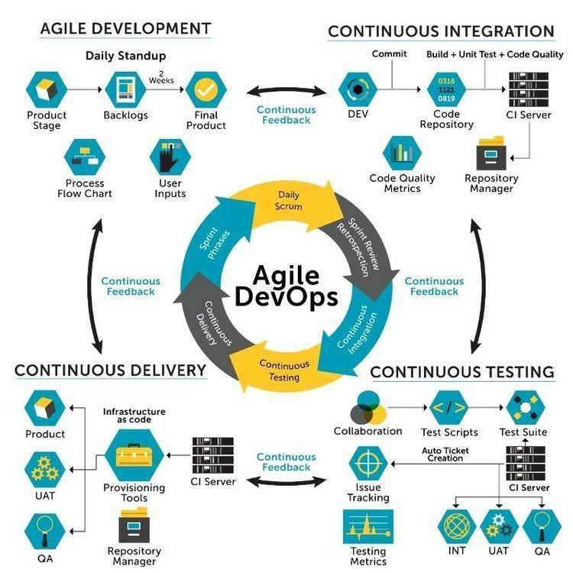

Verbat’s philosophy has been to deliver products that allowed clients to be intimately involved with the development activity. As early as 2005 Verbat had adopted the agile development practices into its pipeline for software development. This allowed clients to closely observe the product being developed. It created a tight feedback loop that allowed us, along with our clients to better understand the requirements and build a right sized and proportional product.

With the advent of next generation applications and tools that support a wide range of activities related to development, deployment and integration; the feedback loops became tighter and coupled, while at the same time it allowed us to create applications that were decoupled. Thus giving us the capability to have greater flexibility in development and deployment.

While development broke down the barrier between developers and management, Devops broke the barrier between software developers and operations teams. Our development and operations teams work under a single silo. While our Scrum teams are cross functional, in our quest to adopt better integration with operations, we have realized that Devops is not just a set of tools and processes, but a mindset and culture. We have fostered a culture collaboration and communication. Our scrum teams and Devops teams share a symbiotic relationship and they work united towards a common goal.

As a company, we have adopted the following tenets in our Devops philosophy

**Speed:** i.e. Move at a high velocity so as to innovate faster for customers and adapt to changing markets better, and grow more efficient at driving business results.

**Rapid Delivery:** Increase the frequency and pace of releases so we can innovate and improve products faster and thus respond to customers’ needs and build competitive advantage.

**Reliability:** Ensure the quality of application updates and infrastructure changes so we can reliably deliver at a more rapid pace while maintaining a positive experience for end users.

**Scale:** Operate and manage infrastructure and development processes at scale.

**Improved Collaboration:** Build more effective teams under a DevOps cultural model, which emphasizes values such as ownership and accountability. Developers and operations teams collaborate closely, share many responsibilities, and combine their workflows.

**Security:** Move quickly while retaining control and preserving compliance. We adopt a DevOps model without sacrificing security by using automated compliance policies, fine-grained controls, and configuration management techniques.

Please see below an illustration of our technology stack. The tools of the trade that allow us to practice an Agile and Devops centric framework

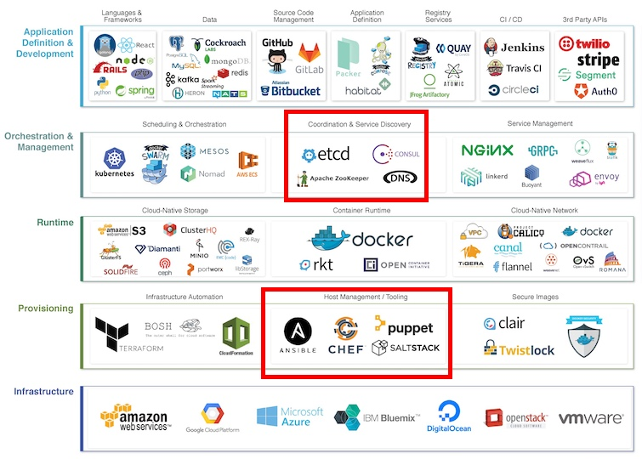

### PROJECT MANAGEMENT

The Verbat development center strictly follows industry standards on quality. Our project management process is governed by the Verbat Quality Management system and is verified through internal audit programs.

Verbat will dedicate a project leader for the proposed implementation. Furthermore, Verbat proposes the client to identify one project manager (*CSPM – Client-Side Project Manager)* who will be driving all activities undertaken by the client, and will be the single point of contact for Verbat.

### ROLES & RESPONSIBILITIES

Verbat will assign its own dedicated Project Lead (*VPL – Verbat Project Lead*) for the client. The VPL will be responsible for planning and management of all activities related to the project. Furthermore, the VPL will work closely with CSPM, on all periodic status updates and will ensure high level visibility and comfort on the progress of the project.

### DELIVERY ACTIVITY SUMMARY

|  |  |
| --- | --- |
| Activities | Description |
| Proof of Concept | Working Model of the project with two languages. |
| Detailed Requirement Analysis | Verbat team to conduct detailed study of requirement for the phase. If clarification is required, the team will reach out to Client for more information and/or time for discussions. |
| DB Design | DB design for central and test DB. |
| Software Requirement Specification document (SRS) | Once the requirement analysis is completed, Verbat team will submit the SRS document for approval |
| UI/UX Design, Prototyping | Based on the SRS, Verbat UX/UI team will work on the UI/UX of the screens and submit prototype for approval |
| Functional Specification Document (FS) | Once the UI/UX is approved, Verbat shall submit an FS document for approval. |
| Development | Actual system development starts based on the FS. This involves detailed design and software development of Web Application. |
| Testing | Test Planning, test plan creations, internal, integration testing and user acceptance testing. |
| Deployment | Deploying the latest build in the Verbat Test Server. |

### PROJECT IMPLEMENTATION PLAN

Verbat will be providing the solution in a stand-alone fixed bid approach which ensures minimum viable solution for quick wins with core focus on the long-term business objective and outcome. Once the implementation is over, Verbat will initiate the application maintenance process (*once the maintenance contract is signed*) which continues to extend after the implementation.

### DELIVERABLES

* Proof of Concept
* Project Plan
* Software Requirement Specification Document (SRS)
* Prototype Design
* Functional Specification Document (FS)
* Fully Developed & Tested Application
* Source Code

### ESTIMATED DELIVERY TIME

The timeline estimated for delivering the application will be as below:

* Working days to complete the proof of concept on completion of resource mobilization.
* Working days to complete the SRS & prototype of Language Translation Application.
* Working days to complete the development.

| **Activity** |
| --- |
| Contract Signoff (T0) |
| Proof of Concept-Allocate Resource |
| Proof of Concept-Complete |
| Proof of Concept- Approval (T1) |
| Detailed Requirement Gathering |
| Software Requirement Specification Document (SRS) |
| SRS Approval (T2) |
| System UI/UX Prototype-Complete |
| System UI/UX Prototype-Approval (T3) |
| Functional Specification (FS) |
| FS Approval (T4) |
| Development Phase-Complete |
| Perform QC (Unit Testing and Integration Testing) |
| System ready for UAT |
| UAT Acceptance on Verbat production server (T5) |

*Note:*

* *The above-mentioned timeline is in Working Days.*
* *Upon project confirmation, Verbat requires a lead time of minimum () working days for resource mobilization for proof of concept.*
* *Resource mobilization will be initiated post the confirmation of the project along with LPO, signed*

*proposal and advance payment.*

* *The initiation of the UI/UX/Prototype development is dependent on the confirmation of SRS.*
* *The above-mentioned timeline for development is post-confirmation of FS.*
* *Documentation submitted after project initiation and system study supersedes any proposal or documentation submitted during initial requirement gathering / discussion / negotiation.*
* *Project plan will be submitted post the confirmation of project with necessary payments.*
* *Any delay in getting the approvals of deliverables from client will cause change in timelines and the revised timelines will be updated in weekly status reports shared with client after the project commencement.*
* *All approvals and queries regarding the client requirement and any queries which may hinder the project advancement at any stage should be answered by the client within () business days from the time of initiation, failing which, the time delay will get added to the actual effort and timeline estimated.*

### DEPLOYMENT DETAILS

* Cloud server for hosting the application will be the responsibility of the client.
* Verbat will deploy the application on client’s cloud server after the client conducts the necessary acceptance testing.

*Note:*

* *Hosting the application at Verbat’s production server (hosting charges) will call in for additional charges. In the event, client wants to procure SSL, the same can be provided by Verbat at additional cost.*
* *Only deployment of the application will be the responsibility of Verbat, any additional installation will be charged separately.*

### RELEASE PLANNING

* Client will be informed about the release date and time through email.
* Client performs the UAT

### RISK CONTINGENCY PLANNING

Verbat has identified various risk factors associated with this assignment and understands the impact of these risk factors on the project schedules. The objective of this section is to highlight for both Verbat and client, the risk factors, to analyze the impact of the risks on project execution, and to propose strategies to control and reduce the impact of the risk factors. These various risks, which could arise during the project, are tabulated below along with mitigation implementation.

| **Type of risk** | **IMPACT** | Risk Mitigation | Risk Handling |
| --- | --- | --- | --- |
| Scope Creep | **H** | Functions and features will be detailed in system requirement document and will go through client approval. Once this document is approved, all changes will go through the change management process for impact assessment. | Proper change management procedure will be implemented |
| Delay in client feedback | **H** | The plan is prepared with sufficient lead-time for reviews and approvals.  The client will advise us on all dates connected to the document review and approval. | The request for feedback will be escalated if not attended to at the right time so that the schedules are not affected. Deemed acceptance criterion is finalized up-front and will be followed |
| Non-availability of necessary software, frameworks, database instances and infrastructure at client’s hosting environment (If hosting support is provided by Verbat) | **M** | Client will be informed in advance on these requirements. | Possible impact to schedule |
| Manpower attrition | **L** | All efforts will be made to ensure that all initiatives are process dependent. To mitigate risk Verbat/Client will train a person to ensure all back-ups are in place. | A new person will be appointed as early as possible, provided the required project-specific training and mentoring is in place - to minimise impact of attrition on the project |

*H-High, M-Medium, L-Low, NA-Not Applicable*

## PROJECT ASSUMPTIONS

The project solution and technology are created from the initial understanding of the requirement shared with Verbat through mails and meetings. The proposed solution is based on the following assumptions:

### OBJECTIVES

* The requirement is to develop a Language Translation Application (web, android, iOS) with the functionalities as defined in ‘Functional Requirements’ section

### DESIGN

* Client to provide Verbat with the brand guidelines.
* Color theme shall be provided by the client.
* Client shall provide licensed images and logos in specified size & format.
* Client shall provide the text and associated images for the proposed application. Text should be provided in digital format preferably in MS Word 2013 or above
* Verbat is free to use custom-made template for design, if required.
* The application designed for mobiles will be in portrait mode

### DEVELOPMENT

* Client shall provide VMware platform for installing the solution
* Client shall install the solution using Jenkins. Verbat shall provide the installation files
* Client record retention for 2 years is contingent upon the client providing Verbat with the hardware to retain the records. Any out of the box solutions (proprietary solutions) recommended by Verbat shall be procured by the client. Verbat shall be responsible for managing the solution
* Client shall educate Verbat on the software services / systems / hardware etc. utilized for the current solution
* It is assumed that all records that needs to be processed to generate reports shall be available from the database or an appropriate API service would be available to access such data
* It is assumed that the context for rate setting revolves around the functionality related to report generation. Verbat shall not be responsible for managing the rate setting within the product such that it enhances the functions related to the core product.
* All reports that needs to be developed shall be predefined by the client. Verbat assumes approximately 6-8 hours for the development of each distinct report. Additional reports not covered within the scope of this proposal shall go through a change management process
* Client shall provide SMS and email providers for generating alerts
* Since the effort for integration of the solution is unknown to Verbat. It has not been included in this proposal.
* Typically Verbat provides support for up to 30 days after product delivery. A 3 year support shall be contingent upon a signed agreement between Verbat and the client towards the provision of such services

1

# **OUT OF SCOPE**

With the ever-evolving digital market, the requirement should be clear to both the parties involved, hence the importance of mentioning the out of scope details of the project. Following are considered to be out of scope while creating this proposal:

* Purchase of images, fonts
* Any language other than English
* Migration of existing data / Database migration
* Content writing / proof reading / Data Replication / Manual data entry
* Content or image procurement or uploading or editing
* Native iOS App Development / Android App development
* Developer account creation and Maintenance (*IOS and Android Store*)
* Adding new features to the application other than mentioned in the functional specifications. Such requests will be handled via change management. For Change management details, please refer to section titled “Change Management” in the Proposal. (*refer page no: 33*)
* Annual Maintenance Contract (*Bug fixing, debugging, enhancements*) – Please refer to section titled “Maintenance and Support”, unless contracted for. (*refer page no: 34*)
* Hosting Infrastructure and Maintenance (*web and email hosting*), unless contracted for.
* Backup solution and Disaster recovery unless contracted for.
* Physical deployment on-site / installation of the application in devices and physical connection, installation of system.
* Integration with third-party, if any, other than mentioned in the functional specifications
* Hardware Integrations / procurement and purchase
* Procurement of SMS gateway / payment gateway / email gateway
* Integration of SMS gateway / payment gateway
* SSL Purchase and installation, if any
* Plugin/template purchases, if any
* API purchases
* OS other than mentioned in the Hardware Interface
* Relevant / related software libraries
* Mobile offline access or operations

# **CHANGE MANAGEMENT**

Any addition which comes out of the project scope, upon and after the launch of the website will be considered as change management. Verbat recommends the following change management procedures for the same:

* Changes will be implemented only after raising a change request.
* Change requests will be studied and an impact analysis will be performed on the existing work flow.
* Upon assessment of the impact, effort estimation will be calculated and raised as an additional requirement.
* The change request will be initiated only after receiving a formal approval from the client for the additional changes raised.
* Changes which are out of scope will be charged @ per man day rate.

Activities for change scheduled

Modules checked in

Unit testing done

Change request accepted

Informed of the Action

Implementation of changes

Modules checked out

Activities planned and scheduled

Effected modules identified

New system released with change request

Changes made & documented

System

Need for change recognized

User submits change request

Evaluate for cost, schedule & effort

Change control authority

yes

No

## MAINTENANCE & SUPPORT

* Maintenance contracts by default are supported as per the basic SLA terms.
* AMC with Basic SLA is charged at % of the total project value. Additional Effort/change management request will be added towards Total Value of the Project to determine the AMC value.
* Maintenance support is limited to providing application support for ensuring the consistency of the look-and-feel, bug fixes and user issues i.e. maintenance and support of the existing features of the application.
* Support does not in any way cover providing technical or other support to the end users or hardware support. The maintenance agreement does not include functionality changes or feature additions which are handled as change requests which will be charged per man day rate. AMC does not include server support, maintenance and application deployment.
* AMC charges will cover Off-Site Support and Debugging. Support includes E-mail, telephone and video conference (if required). In the event, the application is hosted with the client or if it is a client server development; necessary remote desktop connectivity should be provided for carrying out maintenance activities.
* All maintenance support will be executed by Verbat off-site team. In the event of any need for on-site work, all expenses incurred for such trips (flights, accommodation, meals transportation) will be payable to Verbat by client.
* Gap in AMC - In case if the client does not opt an AMC for a year and wants to renew it after that period, % of the AMC amount for the year for which AMC is not taken will also be payable if the client wishes to renew the AMC contract.

|  |  |  |  |  |
| --- | --- | --- | --- | --- |
| **SLA Type** | **Max Response Time** | | **Max Resolution Time** | **Target** |
| Basic | 1 working day | 3 working days | | Request / incident / problem tickets |

*Note:*

* *Time zone applicable as per India Time Zones (3:30 GMT to 12:30 GMT, Monday to Friday)*
* *Please note that the AMC support shall start only after all the necessary sign-offs (AMC Document) to this effect have been given.*
* *It is not mandatory that the client should opt for an AMC. The client will still be supported on an ad-hoc basis on an agreed man-day rate.*
* *AMC Payment Terms: 100% to be paid as advance.*

AMC Option: Client can opt for time and material based Annual Maintenance, the details of which will be shared post the completion of project.

# **TERMS AND CONDITIONS**

## ACCEPTANCE CRITERIA

* UAT (User Acceptance Test) sign off should take place within Days from the first release of the application and the acceptance confirmation needs to be mailed to Verbat failing which Verbat will consider the project as approved by the client.
* Any comments and reasons for rejection need to be documented and the same needs to be sent as an email from the official e-mail id of client to Verbat on or before days from the first release.
* Timeframe for acceptance for any further release will be mutually agreed and finalized between client and Verbat depending on the UAT Comments

## WARRANTY

* Verbat shall provide a bug ﬁx warranty at no additional cost for 30 days from the date of acceptance of the project, for correction of any errors in the developed application that may be attributed to Verbat.
* However, this does not cover modifications by Client, or use of the application on an environment other than the proposed environment, or other circumstances outside Verbat’s reasonable control. In such cases Verbat reserves the right to charge for its services.
* All error corrections will be executed by Verbat offsite team. In the event of any need for on-site work, all expenses incurred for such trips (flights, accommodation, meals, transportation) will be payable to Verbat by Client.

## SOURCE CODE & INTELLECTUAL PROPERTY RIGHTS

* Upon completion of the Project and 100% completion of the payment, the client will have access to the source code except for proprietary codes, developer tools and third-party applications etc.
* The solution offered will be the intellectual property of the client and will be made available to the client on an “unlimited license” basis.
* No person or organization, other than Verbat or any person authorized by Verbat in writing, has permission to modify/change the software solution to be eligible to get continued support from Verbat as per the support terms defined under this document.
* Verbat accepts no liability or damages of any kind arising out of use or non-use of the software delivered. The responsibility of testing of software lies with the client.

## GENERAL TERMS AND CONDITIONS

* Offer Valid for 30 calendar days from the date of submission of the Proposal.
* An average of 20 working days are assumed in a month.
* All the development activities will be carried out from our off-shore development center in India.
* All the documentations will be provided in English.
* Third party components may be used to develop this application.
* The scope of the project is to develop the application as detailed in the scope of the project and mentioned in this proposal. Any changes or additions will have to go through our change management process.
* This proposal is derived and concluded from either the RFQ /RFP/data shared via email / information transferred during an initial requirement analysis meeting / tele-conversation. Verbat reserves the right to change the terms of this proposal if the final terms (including the costing), features & functionalities and timelines are changed during the course of the project. Hence any fees quoted / timeline committed in this proposal may not be considered as final unless agreed upon and signed by both parties.
* Web Application will be best viewed only in the environment mentioned in the section Browser Compatibility.
* Mobile app will be best viewed only in the environment mentioned in the section Hardware Interface.
* All source codes and other project artifacts will adhere to the Verbat document templates and internal coding standards.
* The documents delivered to the client include the ones mentioned under ‘Deliverables’ and these will adhere to Verbat’s internal document standards.
* Acceptance criteria shall be based on the clauses which were mutually discussed between Verbat and client at the Requirement Analysis phase. The same will be documented and approved by both parties through official emails.
* In the event that the Client requires any extension of the proposed acceptance schedule, the associated effort and cost of such extension will be mutually reviewed.
* If the project needs to be put on Hold / Stopped, a minimum notice period of 1 week is required along with the duration of the holding period. Thereafter Verbat will make a final decision based on the request.
* If deployment is done in the client’s server, Verbat will not be held responsible for any performance issues arising due to hardware malfunctions.
* The Client is responsible for all data-backups in case the application is not hosted on the Verbat server.
* All source codes will only be delivered or uploaded on the production server after the due payments are made to Verbat.

## GENERAL ADMINISTRATIVE, TECHNICAL & FUNCTIONAL ASSUMPTIONS

* Detailed system study is required before the start of the project.
* During the requirement gathering phase, authorized personnel from the Client’s side are expected to be available for discussions and finalization of the HLD (High Level Design), before the development commences.
* Type of reports, formats if under the scope of the project, need to be specified by the Client before the project sign off.
* Workflows if under the scope of the project, need to be specified/ confirmed by client before project signoff.
* Verbat assumes that all sign-offs from the Client will be provided within the agreed and specified timeframe.
* Client will provide all the necessary contents, both text and imagery, before starting the project in the format suggested by Verbat (if any).
* The client should provide the relevant information and data, well in advance of the execution of the related activity. Non- availability of this information or data may lead to an interruption of work, which may result in a delay in delivery as well as additional costs to the client.
* The Client should possess a server with the technical specifications recommended by Verbat for the proposed application.
* The Client will be provided with a one-time training (train the trainer) on how to use the application via a video conference (maximum of 4 hours). Additional training requests will be charged at cost to the client.
* Cost of all third-party components to be borne by the client.
* Application will support in three languages which are supported by Google Text to Speech API.

# **FINANCIALS**

## Call Billing Platform

|  |  |  |
| --- | --- | --- |
| Sl. | Description | Amount (USD) |
| 01. |  | XXXX USD |

*Note:*

* *The above cost is exclusive of VAT applicable in UAE*
* *The above cost includes the cost of third-party service of non-translated calls.*
* *The above cost does not include third-party API purchases.*
* *The above estimate is based on the initial understanding of the requirement grounded on the details shared by client via meetings and tele-conversations. If Verbat finds during the requirement gathering phase that the actual requirements uncovered are different form the original, this might affect the estimates provided and Verbat shall exercise rights to renege on the contract. Clarifications/Changes in the scope during system study/ analysis may call in for additional effort and timeline.*
* *For feature additions, please refer section titled “Change Management “.*
* *LPO to be raised in the name of “Verbanet Technologies LLC” for project initiation*

## PAYMENT TERMS

* % of the proof of concept as advance.
* % of proof of concept on delivery of POC
* % of Language Translation Application as advance.
* % of Language Translation Application on completion of:
* SRS
* Prototype
* % on completion of development in UAT release of the Web Application on Verbat server/Mobile build.
* % of Language Translation Application to be paid on UAT Signoff.

*Note:*

* *Payment should be made within 7 days from the date of invoice.*

### MODE OF PAYMENT

Wire transfer to our bank account

|  |  |  |
| --- | --- | --- |
| Particulars | **Option 01** | **Option 02** |
| Bank Name | Commercial Bank of Dubai | Emirates NBD |
| Account Name | Verbanet Technologies LLC | Verbanet Technologies LLC |
| Account Number | 1000305555 | 1011492858201 |
| Swift Code | CBDUAEAD | EBILAEAD |
| IBAN Number | AE840230000001000305555 | AE61 0260 0010 1149 2858 201 |
| Bank Address | Al Qusais Branch, P.O Box 2668, Al Qusais | Mamzar Branch, Dubai |

*Note:*

* *Bank charges incurred during wire transfer to be borne by the client.*
* *Any local taxes / VAT applicable to be borne by the client.*
* *Client invoices will include VAT charges in addition to the application cost.*



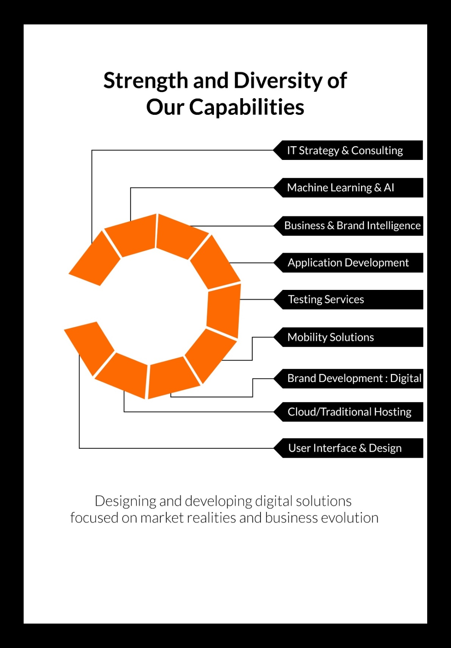

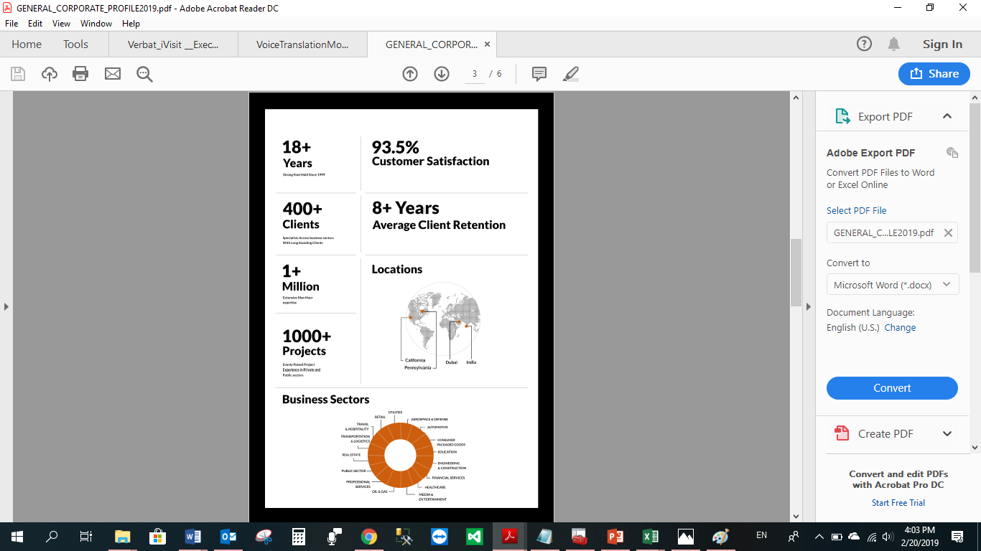

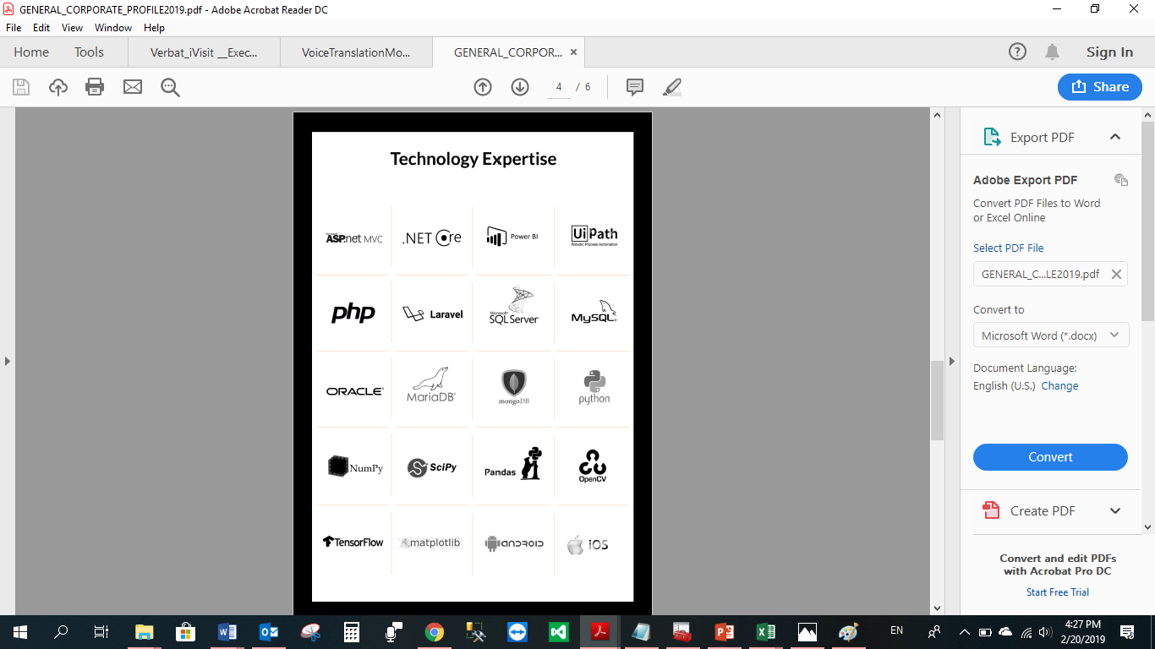

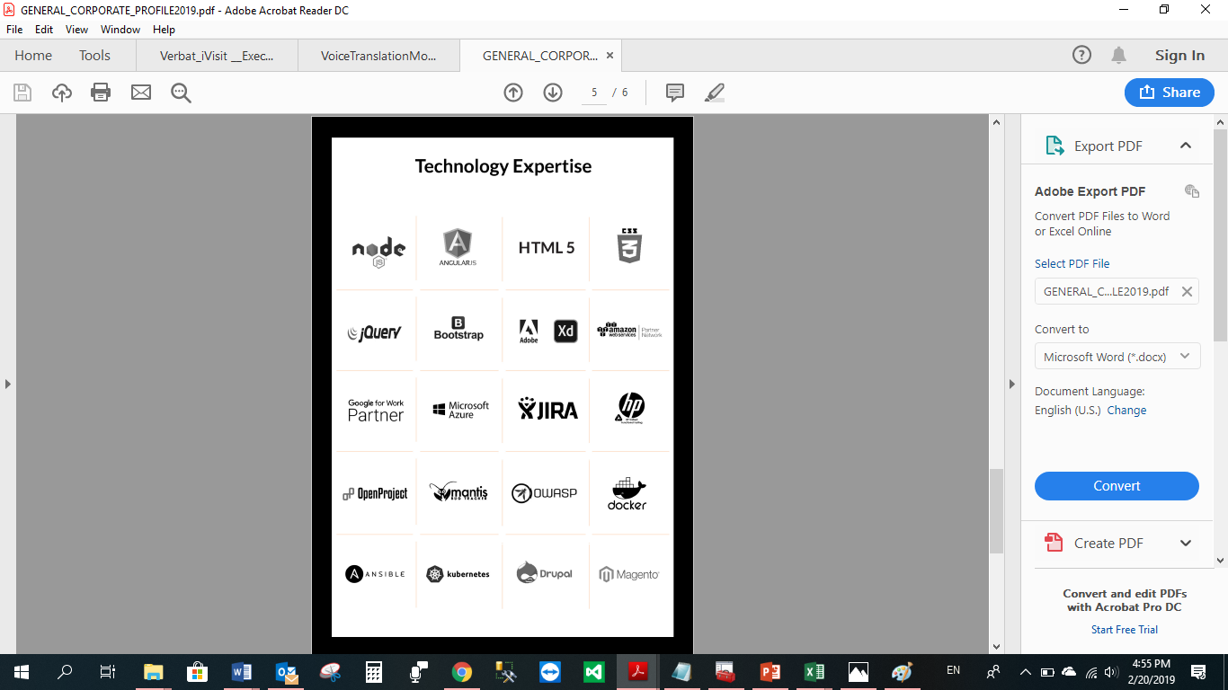

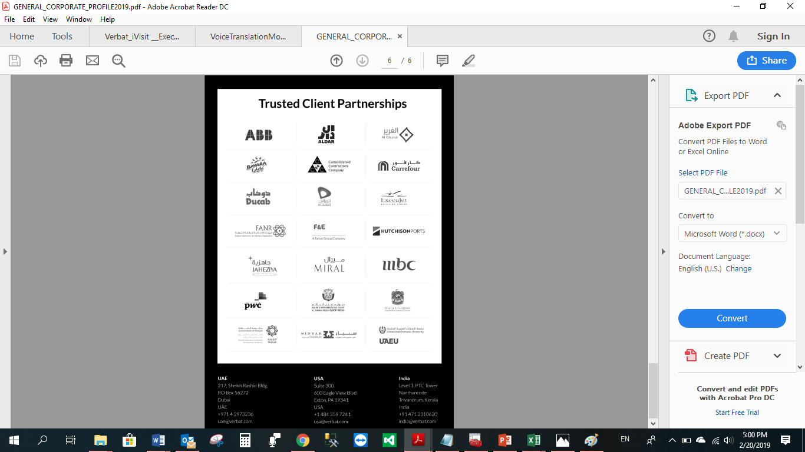

**WITH OUR**

**SINCERE THANKS.**

CONFIDENTIALITY NOTICE:

This Proposal is conﬁdential and contains proprietary information and intellectual property of Verbanet Technologies LLC. Neither this proposal nor any of the information contained herein may be reproduced or disclosed under any circumstances without the express written permission of Verbanet Technologies L.L.C (hereby known under its brand name of Verbat in the United Arab Emirates). 2019. All Rights Reserved.